Myrtle Beach Report

(Student’s name)

(Affiliated Institution)

(Course)

(Date)

Myrtle Beach is on South Carolina's Atlantic Coast and fills in as an excursion resort rivaling famous objections, for example, the Caribbean. The city brags of a critical number of guests, which ignores the roughly 30,000 occupants, every one of whom will appreciate the warm climate, wide seashores, and a different range of diversion exercises, live theater, feasting, shopping, nightlife, and golf. The seashore fills in as the home to summer homes, oceanfront condominiums, skyscraper resorts and lodgings, and more modest "mother and-pop" hotels and inns to serve its different objective crowd (see in photo 1). The structure and arrangement of Myrtle Beach incorporate a few topics and experience parks as a gesture to its solid direction for the family. The historical backdrop of Myrtle Beach as a place of interest begins with the Spanish in 1526, however got famous during the 1900s while it was very provincial (see in photo 2). The name "Myrtle Beach" traded the past name for the area "Long Bay, Withers and New Town" in 1900 (Anderson et al (2018).
The history of this beach incorporates its period being used as a military camp. During the 20th-century myrtle beach was termed as the destination home by the U.S army air corps. To recall this period, both the military personnel as well as the civilians working in the base, this site has got the renowned "wall off service" as part of the warbird park features. The recreation center likewise shows three unique tips of U.S. Flying corps plans positioned on the base. A basic piece of the sea shore's lively history is its golf development and occasions. The eminent notices in the field and the current height of one hundred 18-opening identical courses give a convincing contention to specify Myrtle Beach as the Golf Capital of the World. Myrtle Beach has been isolated from the mainland United States since 1936 by the Intracoastal Waterway, compelling the city and region, as a rule, to create inside a little good way from the coast. To a limited extent because of this partition, the region straightforwardly northwest of Myrtle Beach, over the stream, remained rustic for some time, though its northeastern and southwestern closures were flanked by other created vacationer towns, North Myrtle Beach and Surfside Beach. From that point forward, the inland bit of the Myrtle Beach zone has grown drastically.
Positioned as the second quickest developing metropolitan zone in the nation (per 2018 evaluation gauges), Myrtle Beach is one of the significant focuses of the travel industry in South Carolina and the United States as a result of the city's warm subtropical atmosphere and broad seashores, pulling in an expected 14 million guests every year. As of the 2010 registration, the number of inhabitants in the city was 27,109, and in 2019, the assessed populace was 34,695. The Myrtle Beach metropolitan territory had an expected populace in 2019 of 480,891. Summer thunderstorms can be serious however are brief, and cyclones are uncommon. Typhoons every so often sways Myrtle Beach, however more vulnerable hurricanes and frail tropical lows are more normal. Like most zones inclined to typhoons, an immediate hit by a significant tropical storm is rare in Myrtle Beach. The last tropical storm to cause critical harm in Myrtle Beach was Hurricane Hugo in 1989. The most noticeably terrible tropical storm in Myrtle Beach's set of experiences was Hurricane Hazel in 1954.
Myrtle Beach has an assortment of unique shows, occasions, and melodic shows. The zone's attractions incorporate its seashores and courses, event congregations, an aquarium, Legends in Concert, retail improvements, shopping edifices, and more than 1,900 eateries including fish cafés. The region likewise eats theaters, dance clubs, and numerous vacationer shops. Myrtle Beach has roughly 425 lodgings, with numerous on the beachfront, and around 157 convenience units altogether. The Myrtle Beach Convention Center is an enormous office that has an assortment of gatherings, meetings, displays, and extraordinary occasions each year. The sweeping place, which opened in 2003, has a Sheraton lodging and resort.
Probably the best resource of the Myrtle Beach territory, the climate offers mellow winters and endurable summer temperatures. With a normal high of 57° in the coldest month of January and a normal high of 90° in the most sweltering month of July (see yearly atmosphere diagram), it is once in a while excessively cold, or too hot to even think about enjoying all that Myrtle Beach offers. Snap here to see the current climate. However, The Myrtle Beach government made 15 new laws pointed toward forestalling all endorsed cruiser occasions inside the city because of debate including allegations of prejudice by African-American riders during their occasion and grievances of wilderness and helpless conduct during all exceptionally gone to occasions (Morgan et al (2019). A few claims by the National Association for the Advancement of Colored People (NAACP) against Myrtle Beach organizations were settled with arrangements that segregation stop, remuneration be given to certain offended parties, and representatives are given racial awareness coaching.
The late spring season is long, hot, and sticky in Myrtle Beach. Normal daytime highs are from 83 to 91 °F (28 to 33 °C) and normal evening time lows are almost 70 °F (21 °C). The seaside area of Myrtle Beach mitigates daytime summer heat fairly contrasted with inland regions of South Carolina: Thus, while close by Florence midpoints 65 days yearly with high temperatures of 90 °F (32 °C) or higher – Myrtle Beach midpoints just 21 (Pastore et al (2019). The Bermuda High siphons in mugginess from the tropical Atlantic toward Myrtle Beach, giving summers a close tropical feel in the city. The warm Atlantic Ocean arrives at 80 °F or higher in the late spring a very long-time off Myrtle Beach, making for warm and hot summer evenings. Summer rainstorms are basic in the blistering season in Myrtle Beach, and the mid-year months from June through September have the most precipitation. In summer, rainstorms ordinarily work during the warmth of the day – trailed by brief and extreme deluges. By and large, September is the wettest month, with August not far behind, because of the mix of tempests and heat and humidity frameworks that tops these months.
Photo 1: Aerial view of Myrtle Beach overlooking a theme park, and high-rise
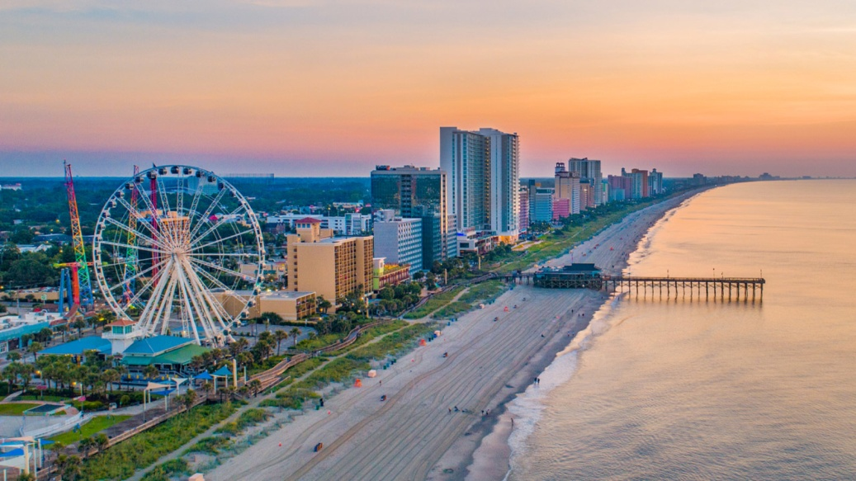
Photo 2: Satellite view of Myrtle Beach
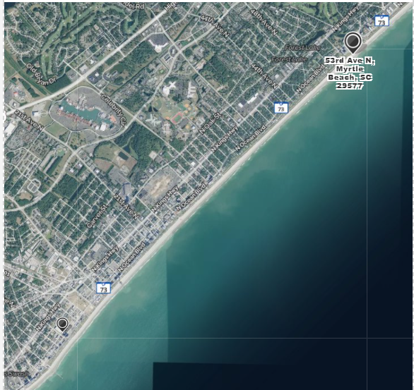

References
Anderson, E., Brantley, D., Knapp, C. C., Battista, B., Gayes, P., & Maschmeyer, C. (2018). Geomorphological Assessment of the North Myrtle Beach (SC) Continental Shelf for Wind Energy Development. southeastern geographer, 58(2), 181-192.
Morgan, K. L. (2019). Baseline coastal oblique aerial photographs collected from False Cape State Park, Virginia, to Myrtle Beach, South Carolina, May 6, 2008.
Pastore, D. M., Peterson, R. N., Fribance, D. B., Viso, R., & Hackett, E. E. (2019). Hydrodynamic Drivers of Dissolved Oxygen Variability within a Tidal Creek in Myrtle Beach, South Carolina. Water, 11(8), 1723.

